SIMATS ENGINEERING (SAVEETHA SCHOOL OF ENGINEERING)
Department of Computer Science and Engineering

ASSESSMENT TOOL 1– Concept Mapping

Course Code: | CSA0310 | Course Title: | Data Structures
CO Assessed: | CO1 – Imitation (BL3, BL4) | Assessment: | Assessment Tool 1 – Concept Mapping
Weightage: | 10% of CIA | Total Marks: | 100
CO1 Statement: | Basics, Data, Data object, Data structure, Abstract Data Types (ADT), realization of ADT in ‘C’, Primitive and non-primitive data structure, Linear and non-linear data structure Arrays & Recursion, Performance analysis and Measurement: Time and space analysis of algorithms, Average, best and worst-case analysis.
Student Name: | Shree Thilak Muthukrishna | Reg. No.: | 192572046
Section / Batch: | B.E. CSE AI | Date: | 22-07-2026
Code of Conduct
I Shree Thilak Muthukrishna(192572046) (Name / Reg No) certify that this submission is my original work and that I have adhered to the guidelines specified for this assessment. I understand that any violation of academic integrity rules will result in disciplinary action.
Signature of the Student:
Instructions
- This test contains 2 concept mapping, Total: 100 Marks.
- Evaluation of Answer Quality -Checking whether the answer includes: Concept Identification , Linkages, Organization, Integration of Literature, and Clarity
- No DTP printouts or electronic devices permitted. They should provide materials in PDF format.

Rubrics

Questions | Problem Understanding | Method Selection | Solution Process | Accuracy of Calculation | Interpretation of Results | Total Marks
Q1
Q2

Annexure A – Concept Mapping

Questions: | EACH QUESTIONS CARRIES : 10 MARKS Duration :ONE HOUR

Q1. A school management system organizes student records class-wise and section-wise. Construct a concept map linking Sequential Storage → Arrays → Hierarchical Storage → Trees → Data Access → Efficiency. Explain how each approach works and justify which method is more suitable for hierarchical data.
Q2. A real-time online examination system processes student responses, evaluates answers, and stores results instantly. Construct a concept map linking Data Flow → Processing → Data Structure Selection
Access Speed → Performance. Analyze how the flow of data influences the choice of data structures and justify the most efficient design.

Q1.

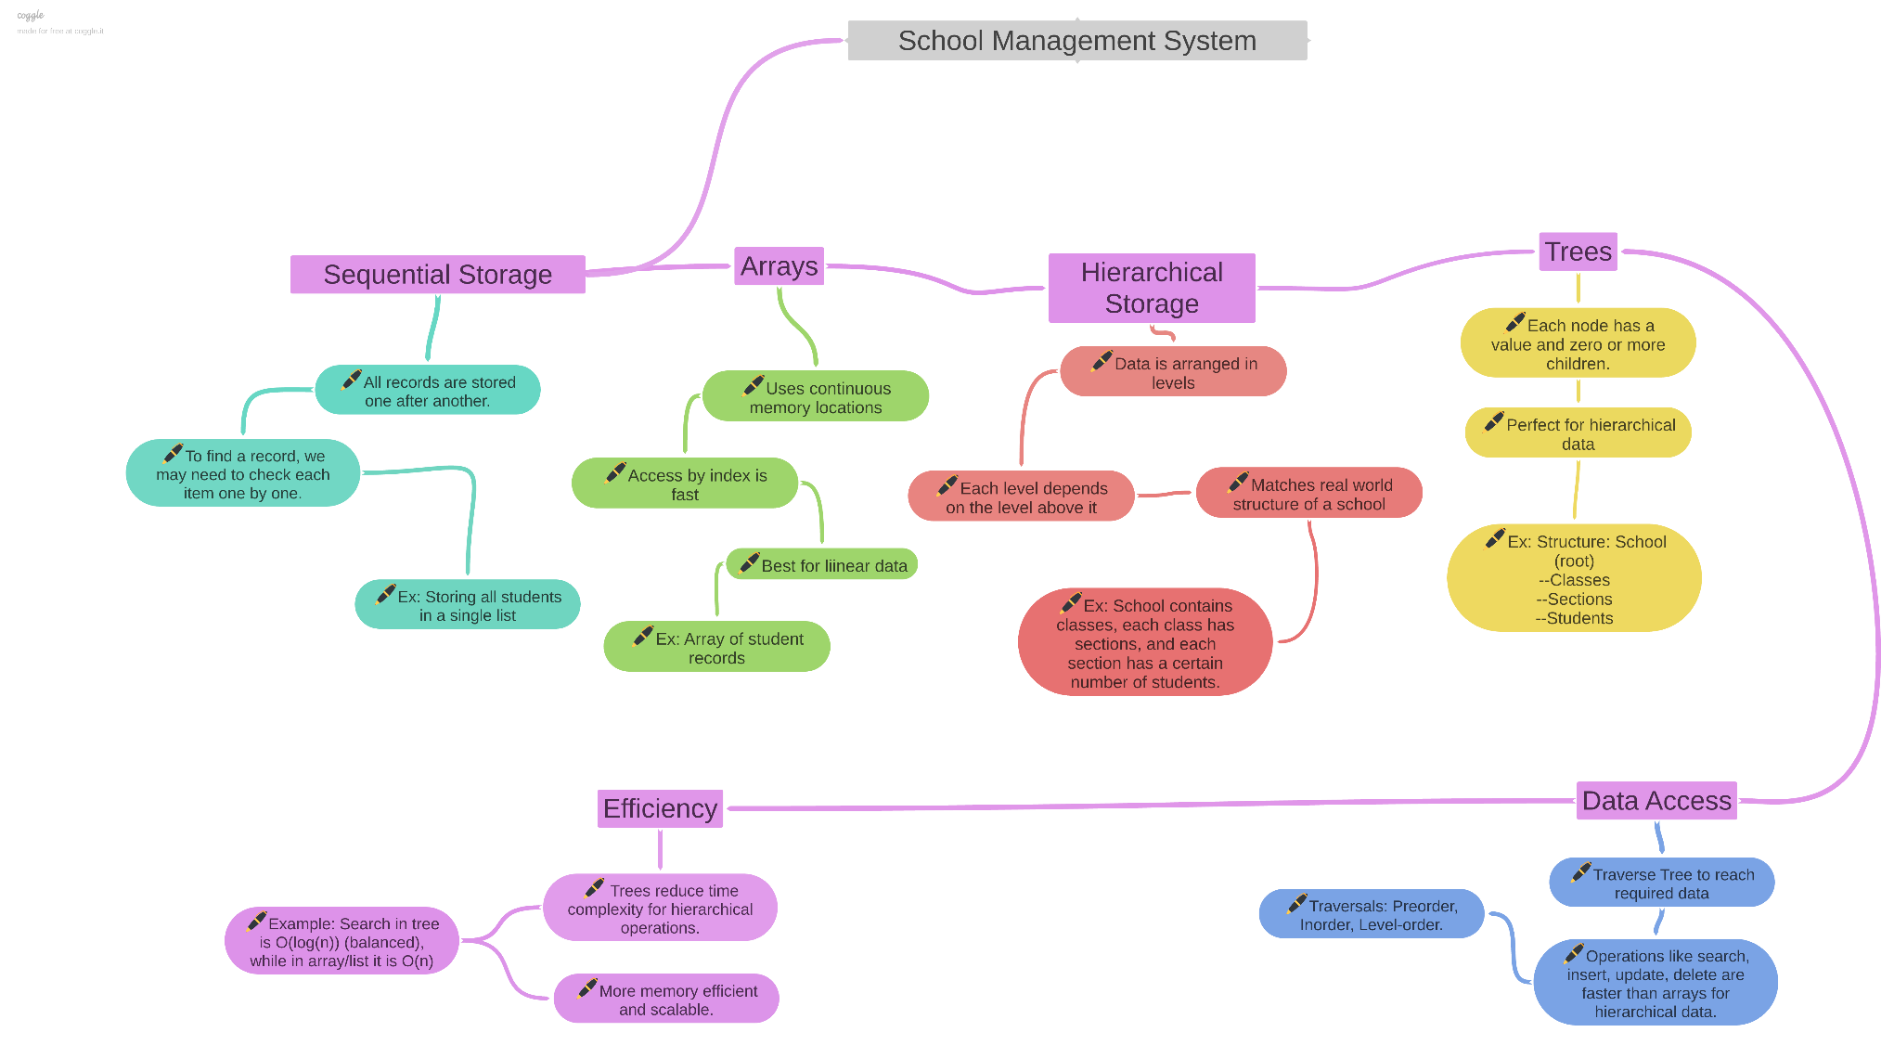

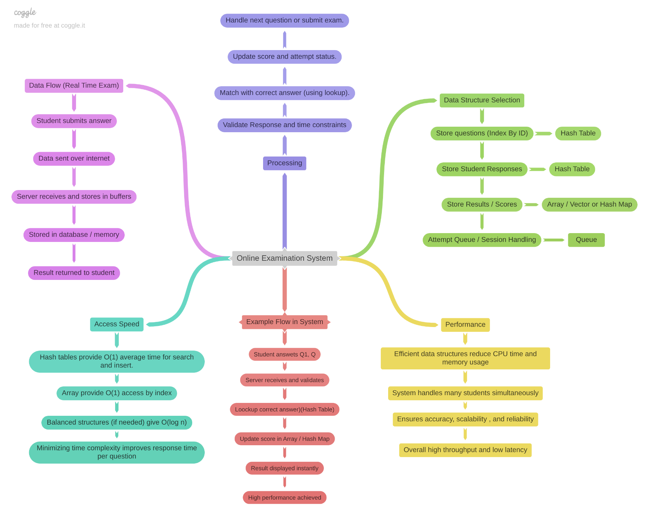
Q2.

